Depth Perception

📘 Definition
# Source: AI Source: Provided by: [Data Path: Persons Table -> ID Column: 1, Name_En Column: Motasem Essam] -> From: [ChatGPT] on [5/2/2026]
Depth perception is the ability to see and understand how far away objects are and how they are positioned in 3D space.
It helps us judge distance, size, and spatial relationships between objects.

👁️ How depth perception works
# Source: AI Source: Provided by: [Data Path: Persons Table -> ID Column: 1, Name_En Column: Motasem Essam] -> From: [ChatGPT] on [5/2/2026]
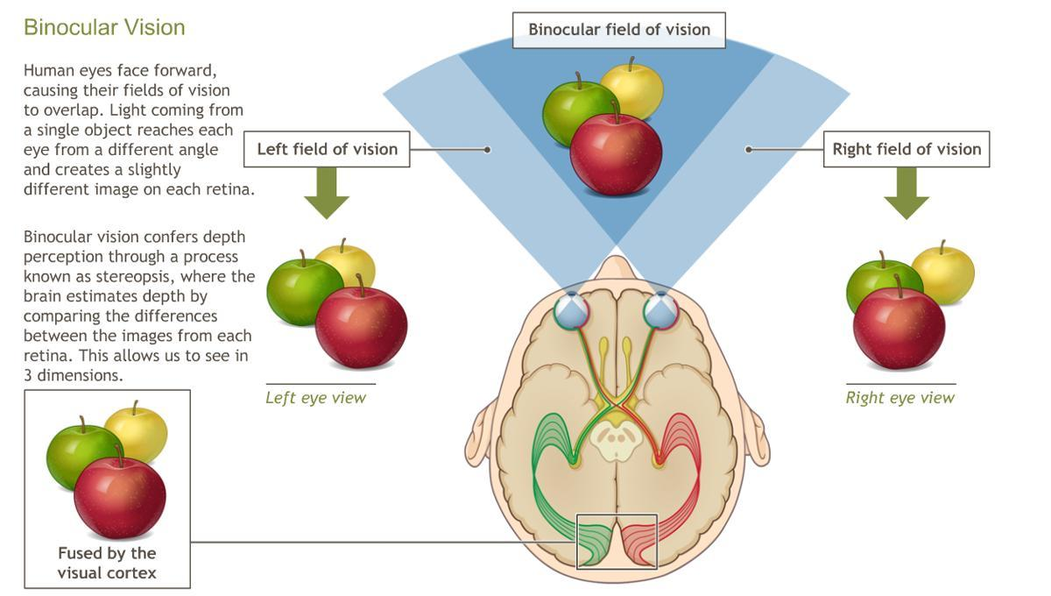
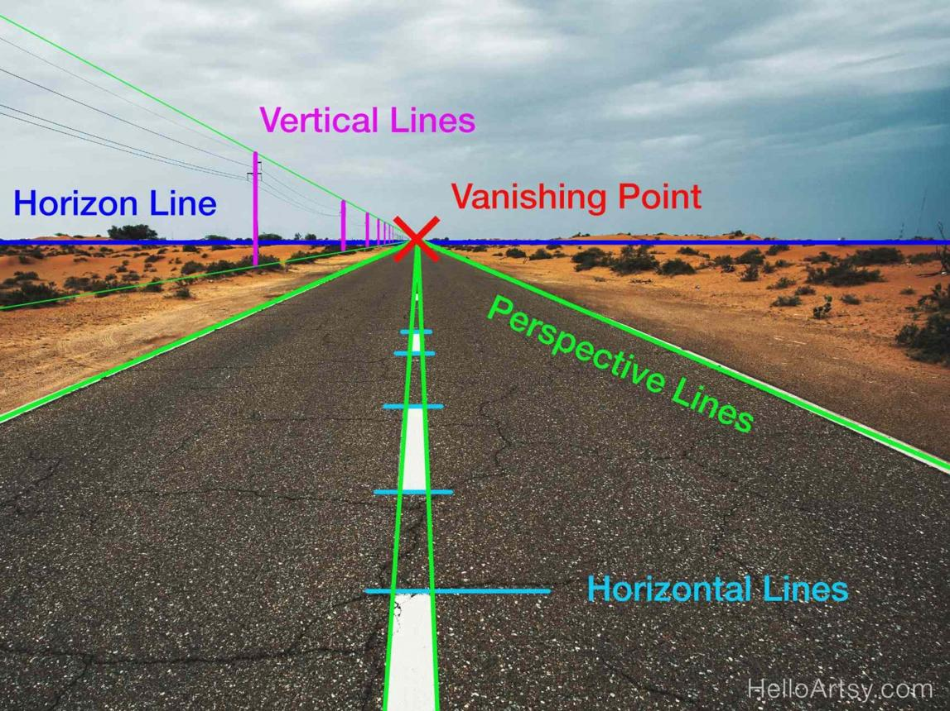
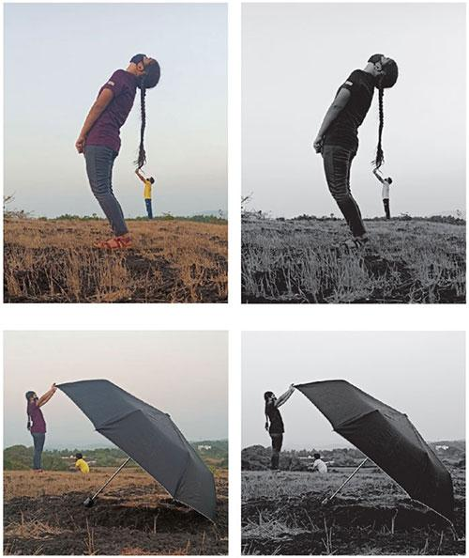
Our brain uses several clues:
- 👁️ Two eyes (binocular vision) → each eye sees a slightly different image
- 📏 Size difference → closer objects look bigger
- 🔍 Overlap → objects in front block others
- 🛣️ Perspective → parallel lines appear to meet far away

🧠 Simple example
# Source: AI Source: Provided by: [Data Path: Persons Table -> ID Column: 1, Name_En Column: Motasem Essam] -> From: [ChatGPT] on [5/2/2026]
Think of:
- 🚗 A car close to you looks big and detailed
- 🚗 A car far away looks small and less detailed
- 🛣️ A road seems to narrow in the distance

🎮 Depth perception in computer graphics
# Source: AI Source: Provided by: [Data Path: Persons Table -> ID Column: 1, Name_En Column: Motasem Essam] -> From: [ChatGPT] on [5/2/2026]
In graphics, depth perception is used to:
- Create realistic 3D scenes
- Show which objects are near or far
- Improve immersion in games and VR
- Add perspective and scale

⚙️ Key features
# Source: AI Source: Provided by: [Data Path: Persons Table -> ID Column: 1, Name_En Column: Motasem Essam] -> From: [ChatGPT] on [5/2/2026]
- 📏 Helps judge distance
- 🧠 Created by brain using visual clues
- 🎯 Important for navigation and realism
- 🖥️ Essential in 3D graphics and animation

🚀 In short:
# Source: AI Source: Provided by: [Data Path: Persons Table -> ID Column: 1, Name_En Column: Motasem Essam] -> From: [ChatGPT] on [5/2/2026]
Depth perception = the ability to see how far away objects are and understand 3D space.

